Project Report Format

1. INTRODUCTION
1.1 Project Overview
The Electric Vehicle (EV) is not new, but it has been receiving significantly more attention in recent years. Advances in both EV analytics and battery technologies have led to increased automotive market share. However, this growth is not attributed to hardware alone. The modern mechatronic vehicle marries electrical storage and propulsion systems with electronic sensors, controls, and actuators, integrated closely with software, secure data transfer, and data analysis, to form a comprehensive transportation solution. Advances in all these areas have contributed to the overall rise of EV’s, but the common thread that runs through all these elements is data analytics.
1.2 Purpose
Visualization tools such as Tableau, Microsoft Power BI, MATLAB, Python, and ArcGIS are widely used for electric vehicle (EV) charge and range analysis. The main purpose of these tools is to convert complex battery and charging data into clear visual formats such as charts, graphs, dashboards, and maps. They help analyze energy consumption, battery performance, charging time, and driving range under different conditions. Through visualization, researchers and companies can identify patterns in charging behavior, predict vehicle range, optimize charging station locations, and improve overall energy efficiency. These tools support better decision-making for EV manufacturers, fleet operators, and policymakers by providing accurate and easy-to-understand insights from large datasets.
2. IDEATION PHASE
2.1 Problem Statement
Customer Problem Statement Template:
EV Charge and Range Visualization Tools are digital modules that transform electric vehicle battery and driving data into simple, visual insights. They display key information such as state of charge, energy usage, and estimated driving range in an easy-to-understand format. These tools help users predict range more accurately, plan trips efficiently, and optimize charging decisions. By presenting complex data clearly, they reduce range anxiety and improve overall confidence in electric vehicle usage.
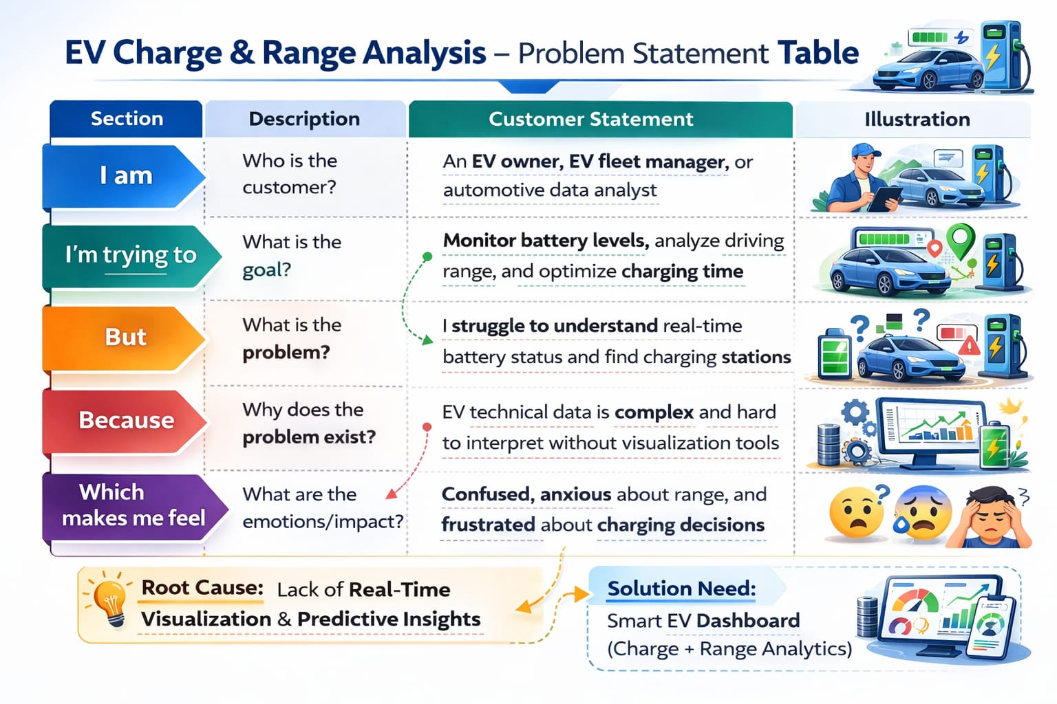
Reference: https://miro.com/templates/customer-problem-statement/
Example:
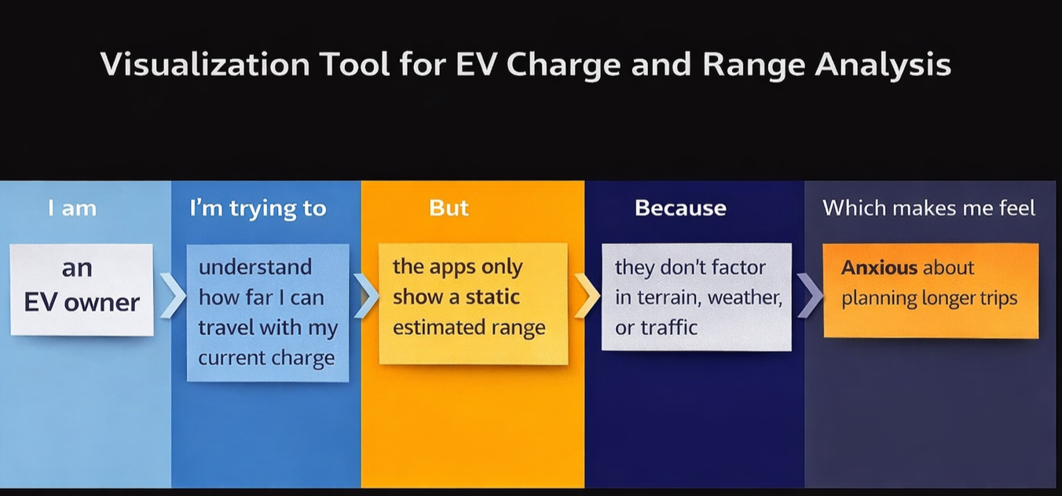
Problem Statement (PS) | I am (Customer)  I’m trying to | I’m trying to | But | Because | Which makes me feel
Ps-1 | An Electric Vehicle owner | Monitor battery charge level and predict remaining driving range accurately | The data is scattered and difficult to interpret | There is no clear, real-time visualization tool integrating battery, terrain, traffic, and driving behavior | Anxious about range and charging availability
Ps-2 | An EV fleet manager | Track vehicle efficiency, charging cycles, and range performance | The analytics tools are complex and not centralized | Vehicle data, charging data, and route data are stored in different systems | Frustrated and inefficient in decision-making

Empathy Map Canvas :
An empathy map canvas helps understand EV users’ needs, behaviors, and challenges when using visualization tools for charge and range analysis. It shows what users think, feel, see, and do while monitoring battery status, charging progress, and range prediction through dashboards and alerts.

This helps identify pain points like difficulty understanding EV data and unclear range estimation, as well as gains such as clear visual insights, accurate predictions, and better trip planning. It supports designing effective tools that improve user confidence and decision-making.

Example:
Reference: https://www.mural.co/templates/empathy-map-canvas

Empathy map

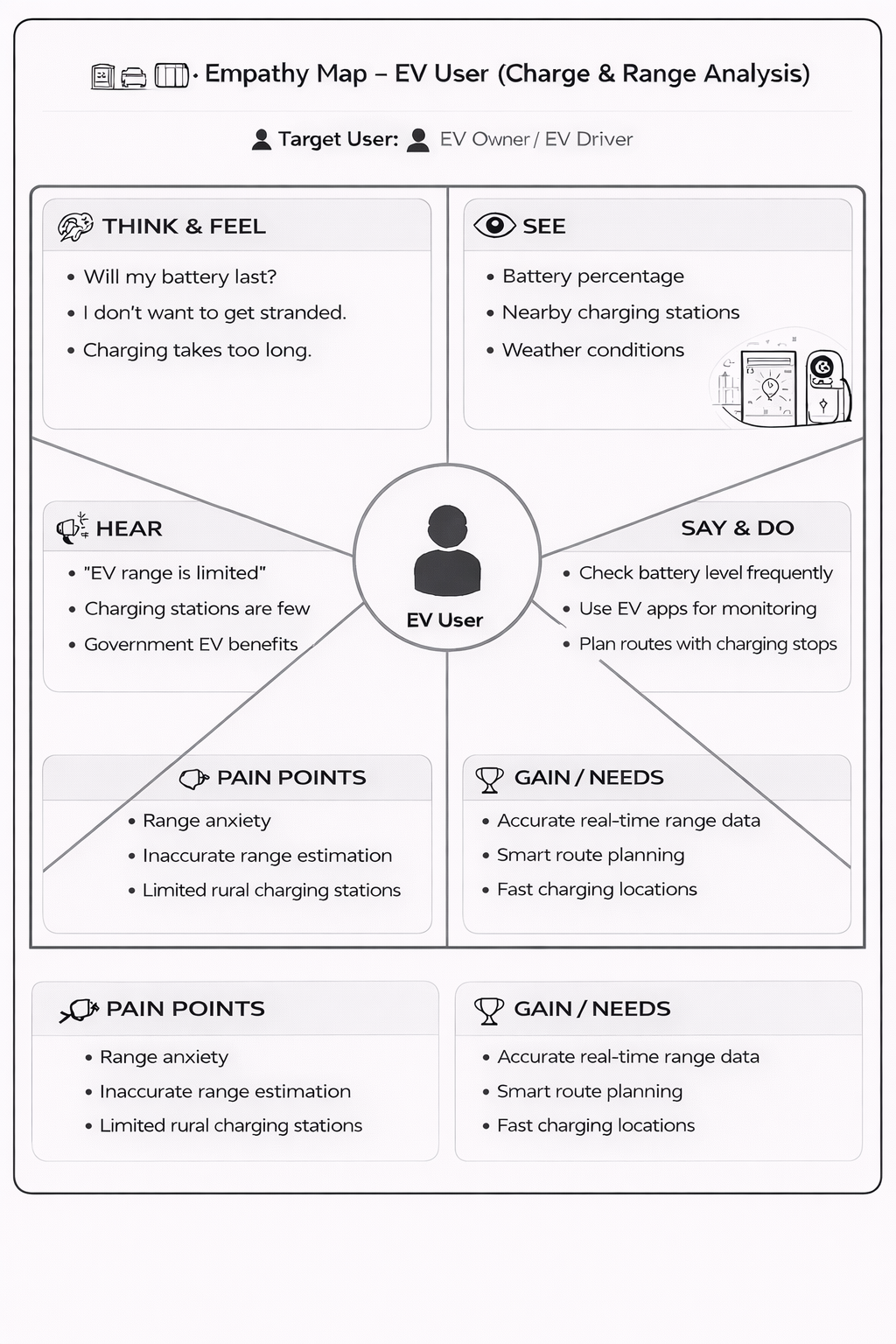
Example:
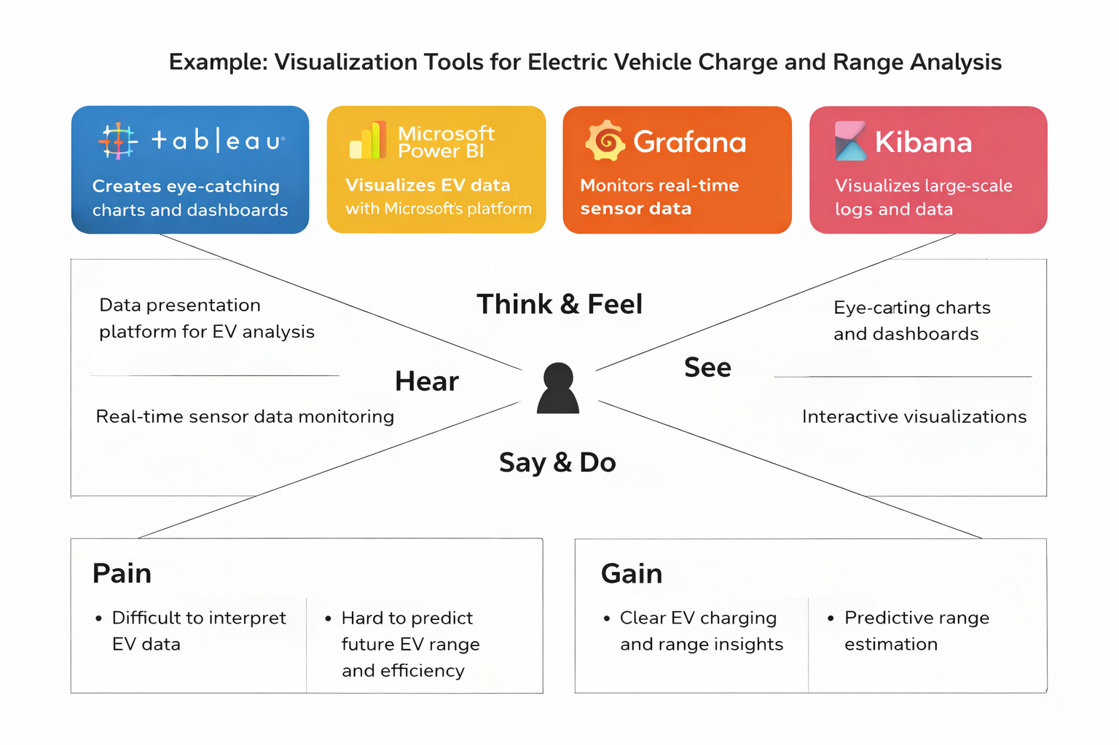

2.3 Brainstorming
Brainstorm & Idea Prioritization Template:
This visualization tool is designed to help electric vehicle users clearly understand, predict, and optimize battery charge and driving range through intuitive, data-driven visuals. It transforms complex energy data—such as battery state, consumption patterns, terrain, weather, and charging behaviour—into easy-to-interpret maps, charts, and interactive simulations.
Reference: https://www.mural.co/templates/brainstorm-and-idea-prioritization
Step-1: Team Gathering, Collaboration and Select the Problem Statement:
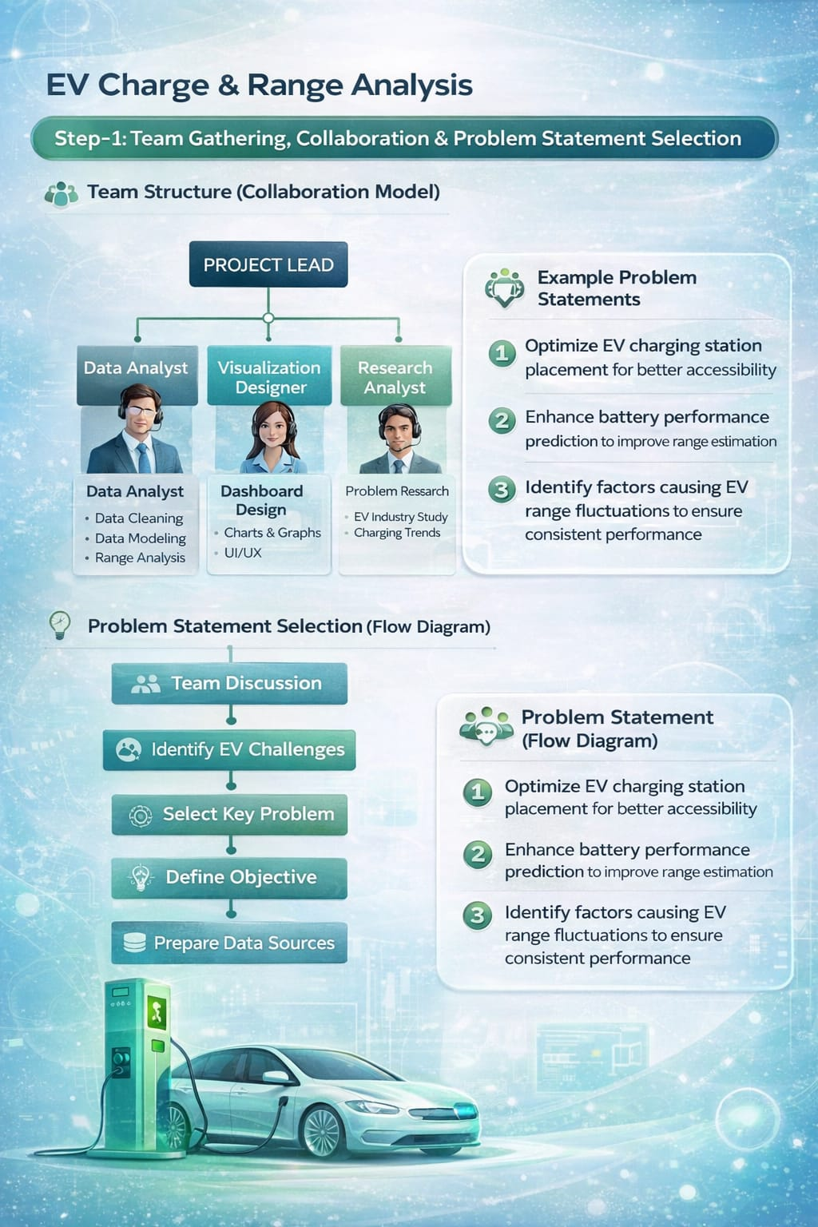
Step-2: Brainstorm, Idea Listing and Grouping
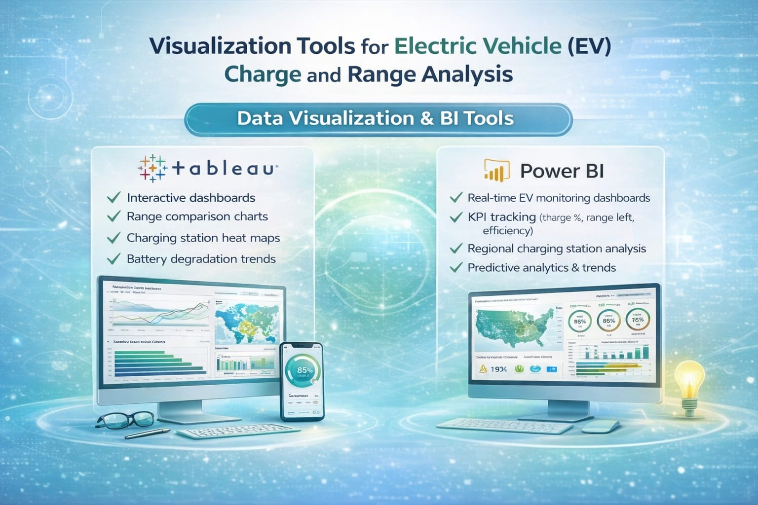

Step-3: Idea Prioritization
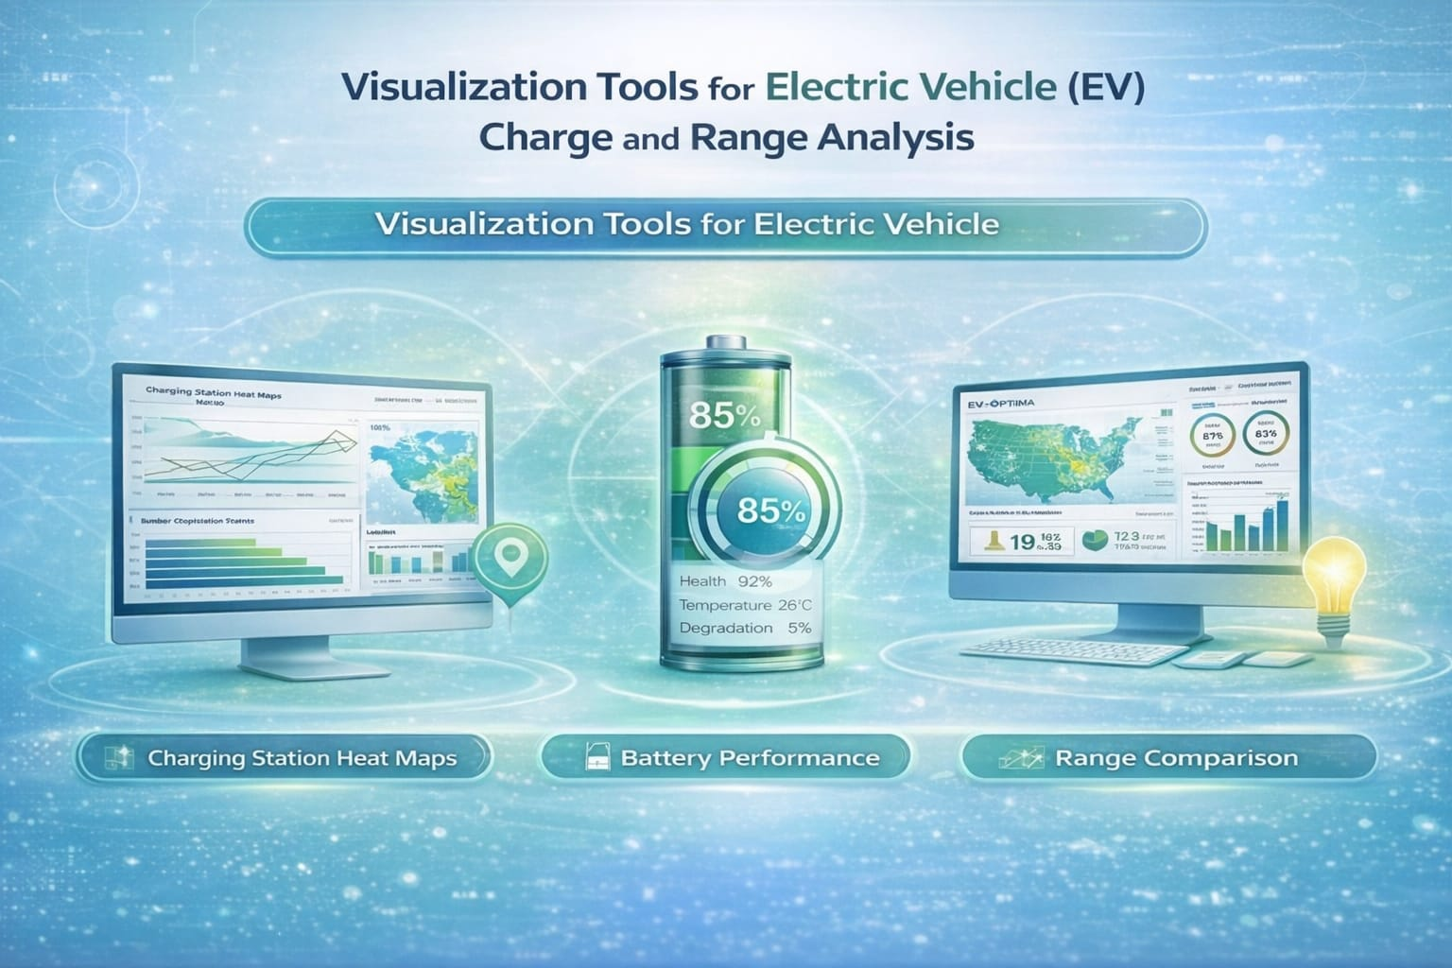
3. REQUIREMENT ANALYSIS
3.1 Customer Journey map
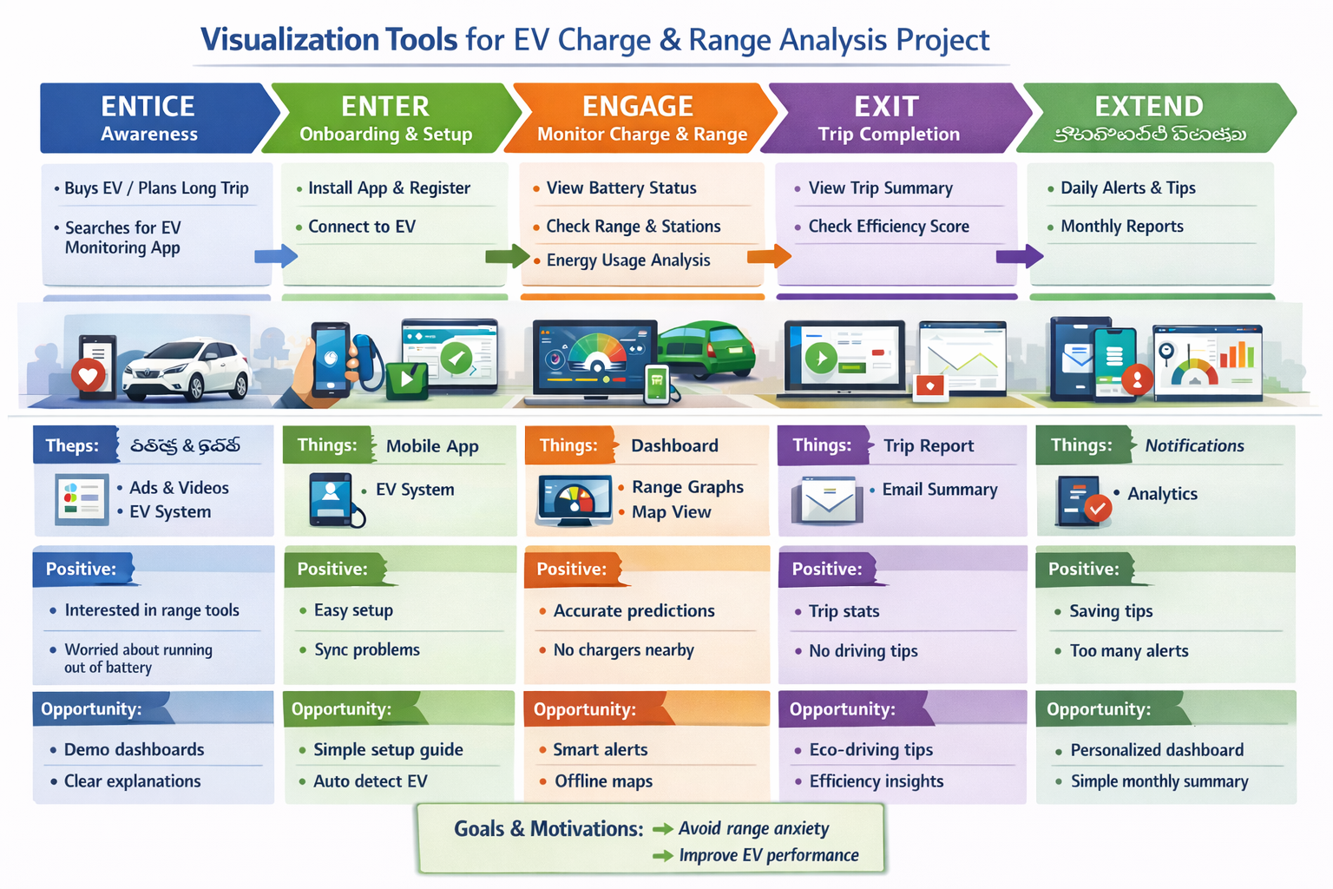

3.2 Solution Requirement
Functional Requirements:
Following are the functional requirements of the proposed solution
S.No | Functional requirements (Epic) | Sub Requirement (Story / Sub-Task)
FR-1 | User Registration & Login | The system should allow users to register using Email or Google account. It should provide secure login authentication and password reset option. User profile management and session handling should also be available.
FR-2 | Data Collection | The system should collect EV battery data such as State of Charge (SOC), voltage, current, temperature, charging session details, and trip distance. It should allow uploading datasets in CSV/Excel format and support real-time data collection through APIs or IoT devices.
FR-3 | Data Processing & Analysis | The system should clean and preprocess raw EV data by removing missing or incorrect values. It should calculate battery charge percentage, estimate driving range, analyze charging time, and compute energy efficiency (km/kWh). It should also generate comparative analysis between different trips or vehicles
FR-4 | Data Visualization | The system should generate interactive visualizations such as line charts (charge vs time), bar charts (range comparison), pie charts (energy usage distribution), and performance trend graphs. Users should be able to zoom, filter, and interact with charts for better understanding.
FR-5 | Dashboard Development | The system should provide an interactive dashboard that displays key performance indicators like total distance traveled, average range, battery health status, and charging history. It should include filters based on date, vehicle type, and trip details for customized analysis.
FR-6 | Web Integration & Reporting | The system should be accessible through a web-based platform with responsive design (mobile & desktop). It should support API integration for live data updates and allow users to download analytical reports in PDF format and export visualization charts.

Non-functional Requirements:

Following are the non-functional requirements of the proposed solution.

S.No | Non-Functional Requirement | Description
1 | Usability | The system should have a simple, clean, and user-friendly interface. Navigation must be easy so that users can quickly access dashboard, reports, and visualizations without technical knowledge.
2 | Security | The system should ensure secure authentication, encrypted password storage, secure API communication, and protection against unauthorized access to EV data.
3 | Reliability | The system should provide accurate calculations and consistent performance. It must handle errors properly when invalid or incomplete data is uploaded.
4 | Performance | The dashboard should load within 2–3 seconds even with large datasets. Data processing and visualization generation should be efficient and optimized.
5 | Availability | The system should be available 24/7 with minimal downtime. Cloud hosting and backup mechanisms should be implemented to prevent data loss.
6 | Scalability | The system should support increasing data volume from multiple EV vehicles and allow future expansion such as integration with additional analytics tools.

3.3 Data Flow Diagram
Data Flow Diagrams:
Data Flow Diagram
Visualization Tools For Electric Vehicle And Range Analysis

Data Collection

Working With Dataset

Data visualization

Dashboard
Performance Testing

Documentation

Web Integration

Story

3.4 Technology Stack
Technical Architecture:
The Deliverable shall include the architectural diagram as below and the information as per the table1 & table 2
Example: Order processing during pandemics for offline mode
Reference: https://developer.ibm.com/patterns/ai-powered-backend-system-for-order-processing-during-pandemics/

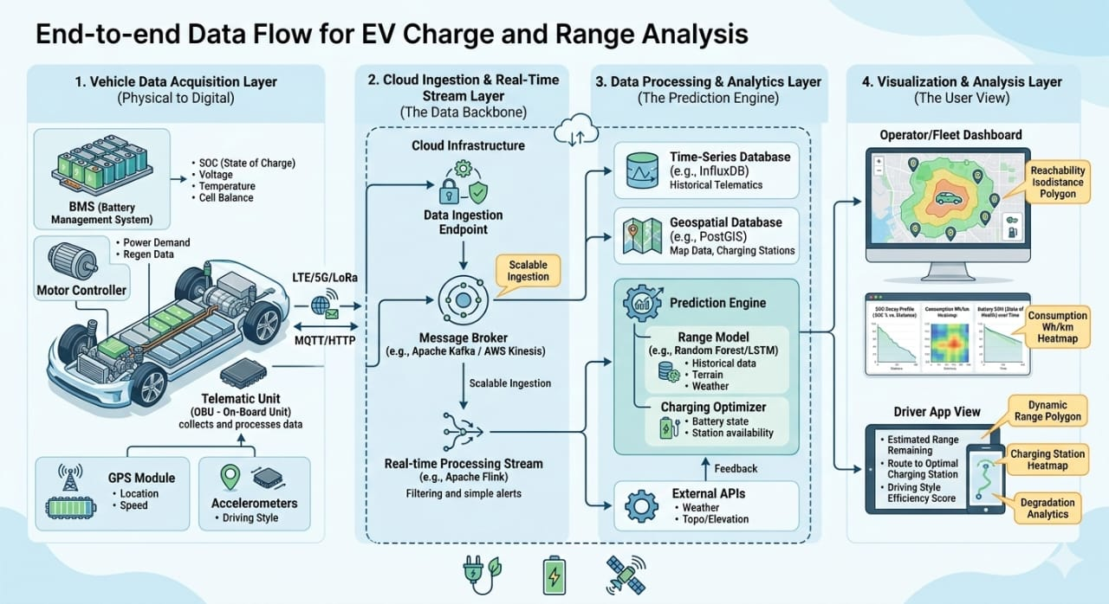

S.No | Components | Description | Technology
1 | User Interface | Dashboard for real-time range visualization, battery percentage (SOC), and charging station map. | HTML, CSS, React.js, Map box GL JS
2 | Application Logic-1 | Range Estimation Engine: Calculates distance based on battery health, road terrain, and driving style. | Python (Fast API), Scikit-learn
3 | Application Logic-2 | Telematics Handler: Manages real-time data flow from the vehicle’s Battery Management System (BMS). | MQTT, Node.js
4 | Application Logic-3 | Telematics Handler: Manages real-time data flow from the vehicle’s Battery Management System (BMS).  MQTT, Node.js | Java / Python
5 | Database | Stores user profiles, vehicle metadata, and fixed charging station locations. | MySQL / PostgreSQL
6 | Cloud Database | High-speed storage for continuous time-series data like battery voltage and temperature.  Influx DB / MongoDB | Influx DB / MongoDB
7 | File Storage | Storage for trip logs, historical range reports, and map data.  AWS S3 / IBM Cloud Object Storage | AWS S3 / IBM Cloud Object Storage
8 | External API-1 | Accesses real-time traffic and charging station status. | Open Weather API, Google Elevation API
9 | External API-2 | Accesses real-time traffic and charging station status. | HERE Maps API, Open Charge Map API
10 | Machine Learning Model | Predictive model used for analyzing long-term battery degradation and consumption patterns.  Random Forest / LSTM Models | Random Forest / LSTM Models
11 | Infrastructure | Cloud-based deployment for scaling services and handling vehicle data streams. | Kubernetes, AWS / Azure
References:
https://c4model.com/
https://developer.ibm.com/patterns/online-order-processing-system-during-pandemic/
https://www.ibm.com/cloud/architecture
https://aws.amazon.com/architecture
https://medium.com/the-internal-startup/how-to-draw-useful-technical-architecturediagrams-2d20c9fda90d
4. PROJECT DESIGN
4.1 Problem Solution Fit :
Problem–Solution Fit means clearly identifying a real and important problem faced by your target customers and developing a solution that effectively solves that problem. It helps ensure that your idea is useful, relevant, and valuable to the market.
Purpose
- Solve Real Customer Problems Develop solutions that match the actual needs and current situation of your customers.

- Increase Adoption Faster Improve success by aligning your solution with existing customer behaviours, habits, and channels.

- Improve Communication & Marketing Use the right triggers, messaging, and positioning to connect with your target audience effectively.

- Build Trust & Engagement Address frequent, urgent, or costly problems to create stronger customer relationships and increase touchpoints.

- Understand & Improve Current Situations Analyze the existing customer environment to design better and more meaningful solutions.

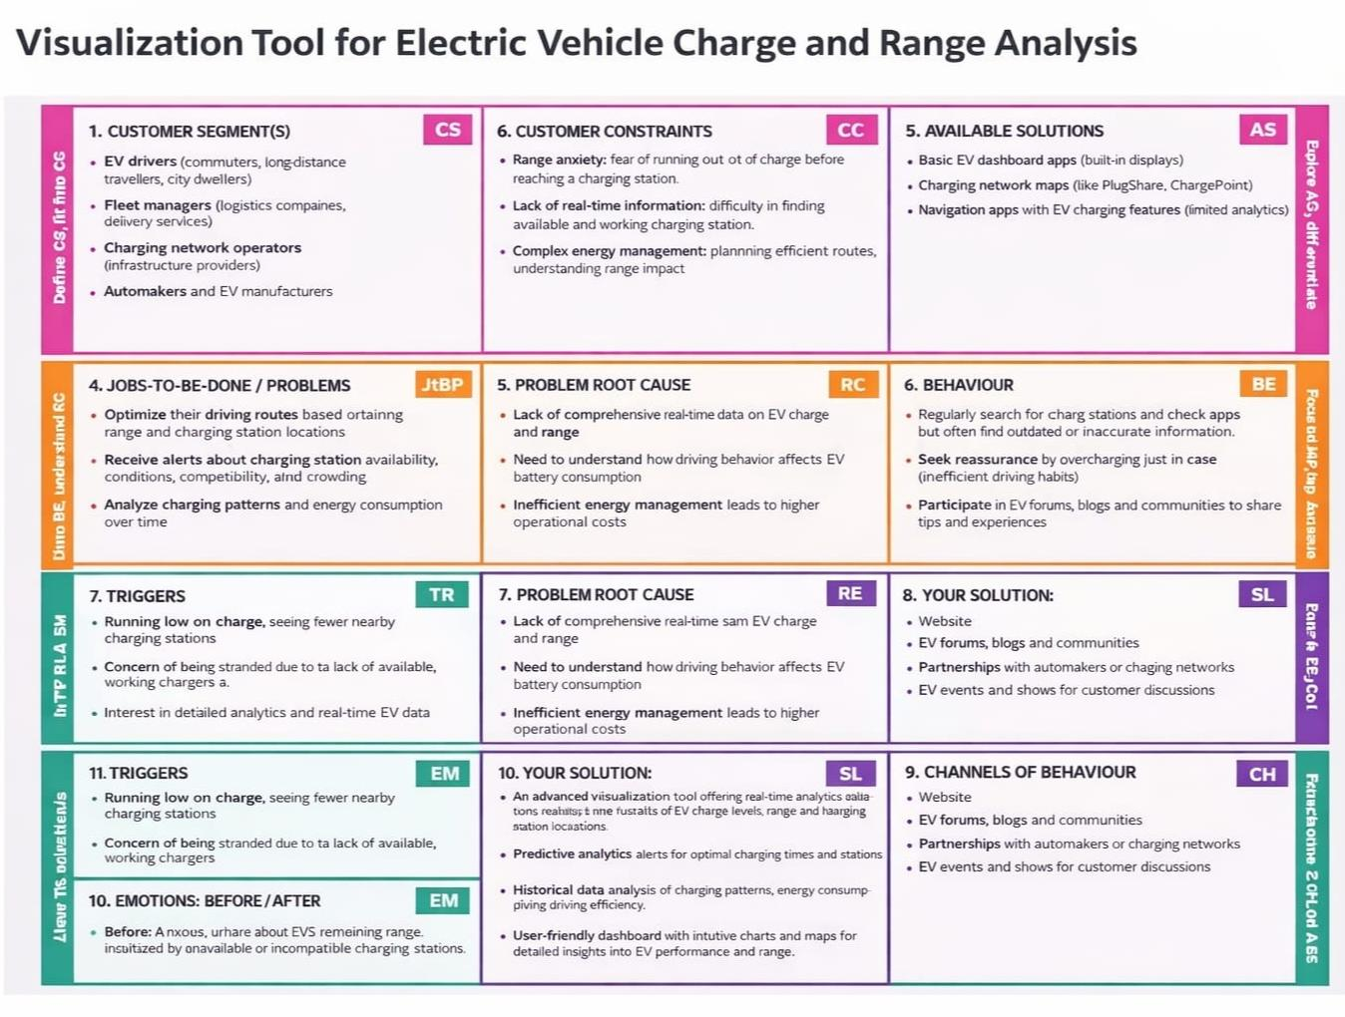
References:
https://www.ideahackers.network/problem-solution-fit-canvas/
https://medium.com/@epicantus/problem-solution-fit-canvas-aa3dd59cb4fe

4.2 Proposed Solution
Proposed Solution Template:
Project team shall fill the following information in proposed solution template.
S.No | Parameter | Description
1 | Problem Statement (Problem to be solved) | Many electric vehicle (EV) users face difficulty in accurately estimating battery charge levels, driving range, and charging station availability. This leads to range anxiety, inefficient trip planning, and inconvenience during travel.
2 | Idea / Solution description | Develop a Visualization Tool for Electric Vehicle Charge and Range Analysis that provides real-time battery status, predicted driving range, nearby charging stations, route optimization, and charging time estimation using data analytics and GPS integration.
3 | Novelty / Uniqueness | The solution integrates real-time vehicle data, AI-based range prediction, weather and traffic impact analysis, and interactive visual dashboards in a single platform. It provides personalized insights based on driving behaviour.
4 | Social Impact / Customer Satisfaction | Reduces range anxiety among EV users, promotes eco-friendly transportation, improves travel convenience, and increases trust in electric mobility solutions. Enhances overall customer satisfaction through accurate and transparent data.
5 | Business Model (Revenue Model) | Revenue can be generated through subscription plans (premium analytics features), partnerships with charging station providers, in-app advertisements, data analytics services for EV companies, and fleet management solutions.
6 | Scalability of the Solution | The solution can be scaled globally by integrating with multiple EV brands, expanding charging station networks, supporting different regions, and adding multilingual support. Cloud-based infrastructure ensures easy expansion and high performance.

4.3 Solution Architecture
Solution Architecture:
Solution architecture is the process of designing and defining how different technology components work together to solve a specific business problem.
- Solution architecture helps to collect data from electric vehicles and charging stations.It transfers the collected data to the cloud for storage and analysis.
- It stores the data securely in databases for future use.
- It processes the data to calculate vehicle range and charging efficiency. It displays the data in dashboards using visualization tools.
- It helps users monitor vehicle performance and make better decisions.

Example - Solution Architecture Diagram:
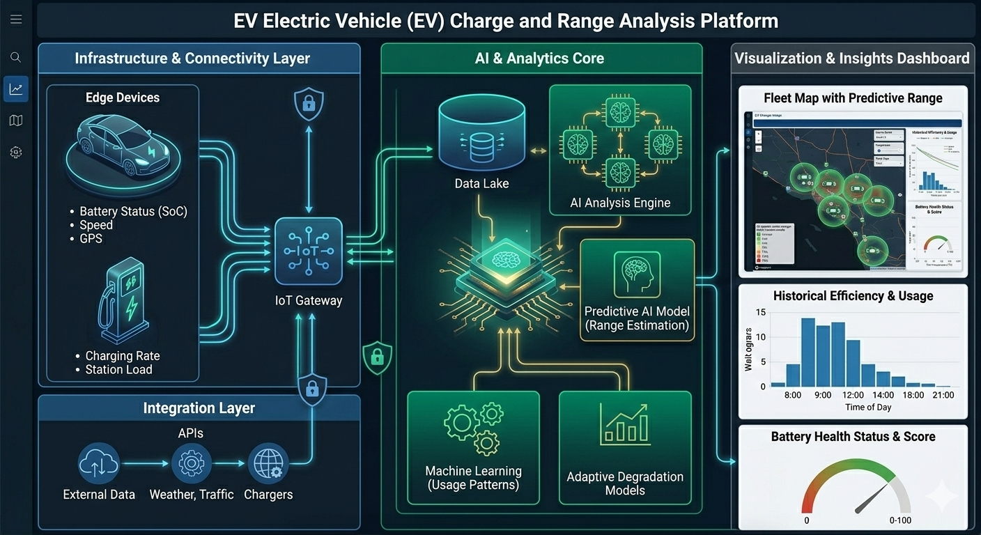
5. PROJECT PLANNING & SCHEDULING
5.1 Project Planning
Product Backlog, Sprint Schedule, and Estimation (4 Marks)
Use the below template to create product backlog and sprint schedule

Sprint | Functional Requirement (Epic) | User Story Number | User Story / Task | Story Points | Priority | Team Members
Sprint-1 | Data Collection Module | Us-1 | As a system user, I can input vehicle battery specifications for analysis. | 3 | High | Sukanya
Sprint -1 | Data Collection Module | Us-2 | As a user, I can record charging session details (SoC, time, energy added). | 5 | High | Sukanya
Sprint -1 | Charging Analysis | Us -3 | As a user, I can generate charging curve (SoC vs Time) visualization | 5 | Medium | Santoshi
Sprint-2 | Working with dataset | Us-4 | As a user, I can calculate energy efficiency (kWh/100km) for each trip. | 3 | High | Santoshi
Sprint-2 | Range Prediction  Working with dataset | Us-5 | As a user, I can estimate the remaining range based on current | 5 | High | Bhavani
Sprint-2 | Visualization dashboard | Us-6 | As a user, I can view interactive graphs for range vs speed and efficiency. | 8 | Medium | Bhavani
Sprint -3 | Dashboard | Us-7 | As a user, I can track battery State of Health (SoH) over time. | 5 | Medium | Anitha
Sprint -3 | Story | Us-8 | As a user, I can calculate charging cost per session and per km. | 3 | Low | Anitha
Sprint -4 | Final Dashboard & Report | Us-9 | As a project admin, I can generate final EV performance analysis reports. | 8 |  | Sukanya  Santoshi

Project Tracker, Velocity & Burndown Chart: (4 Marks)

Sprint | Total story points | Duration | Sprint Start Date | Sprint End Date (Planne | Story Points Completed (as on Planned End Date | Sprint Release Date (Actual)
Sprint -1 | 25 | 7 days | 03 feb 2026 | 08 Jan 2023 | 23 | 09 Feb 2026
Sprint -2 | 18 | 6 days | 10 feb 2026 | 15 Jan 2023 | 18 | 15 Jan 2026
Sprint -3 | 22 | 7 days | 17 Feb 2026 | 23 Jan 2023 | 21 | 20 Feb 2026
Sprint -4 | 20 | 6 days | 18 Feb 2026 | 31 Jan 2023 | 20 | 18 Feb 2023

Velocity:
Assume that the sprint duration is 10 days, and the team velocity is 20 story points per sprint. To calculate the Average Velocity (AV) per iteration unit (Story Points per Day):

AV=total story points/sprint duration
AV=20/1n
Burndown:
A Burndown Chart is a graphical representation of the remaining work versus time during a sprint. It is widely used in Agile methodology to track project progress.
https://www.visual-paradigm.com/scrum/scrum-burndown-chart/
https://www.atlassian.com/agile/tutorials/burndown-charts
Reference:
https://www.atlassian.com/agile/project-management
https://www.atlassian.com/agile/tutorials/how-to-do-scrum-with-jira-software
https://www.atlassian.com/agile/tutorials/epics
https://www.atlassian.com/agile/tutorials/sprints
https://www.atlassian.com/agile/project-management/estimation
https://www.atlassian.com/agile/tutorials/burndown-charts

6. FUNCTIONAL AND PERFORMANCE TESTING
6.1 Performance Testing
The project team shall fill the following information in the model performance testing template.
S.No | Parameter | Screenshot/values
1 | Data rendered | Dataset contains: EV Model, Battery Capacity (kWh), Range (km), Charging Time (hrs), Charging Type, Price, Region. Total Records: 500+. Data successfully loaded into Tableau Data Pane
2 | Data preprocessing | Removed duplicates (5 records). Handled missing values in Charging Time. Converted Range & Battery Capacity into numeric format. Created hierarchy: Region → City.
3 | Utilisation of Filter | Filters Used: EV Model, Charging Type (Fast/Slow), Battery Capacity Range, Region. Screenshot shows interactive filter panel applied to dashboard
4 | Calculation field Used | 1. Efficiency = Range / Battery Capacity 2. Charging Cost per 100km = (Electricity Cost × Battery Capacity) / Range 3. Average Range = AVG(Range)
5 | Dashboard design | No of Visualizations / Graphs – 6 1. Range by EV Model (Bar Chart) 2. Charging Time vs Battery Capacity (Scatter Plot) 3. Range Trend Over Years (Line Chart) 4. Charging Type Comparison (Bar Chart) 5. Region-wise EV Distribution (Map) 6. KPI Cards (Avg Range, Avg Charging Time)
6 | Story design | No of Visualizations / Graphs – 5 Story Points 1. EV Market Overview 2. Range Comparison 3. Charging Performance Analysis 4. Regional Insights 5. Strategic Recommendations

7. RESULTS
7.1 Output Screenshots
Data visualizations
Charging Stations by region and type in India:
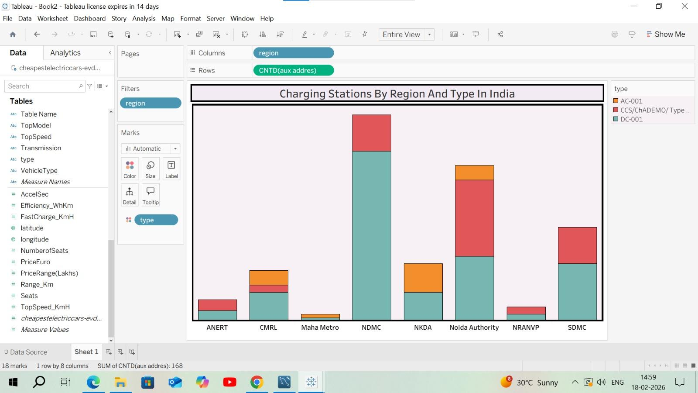

EV Charging stations map of India: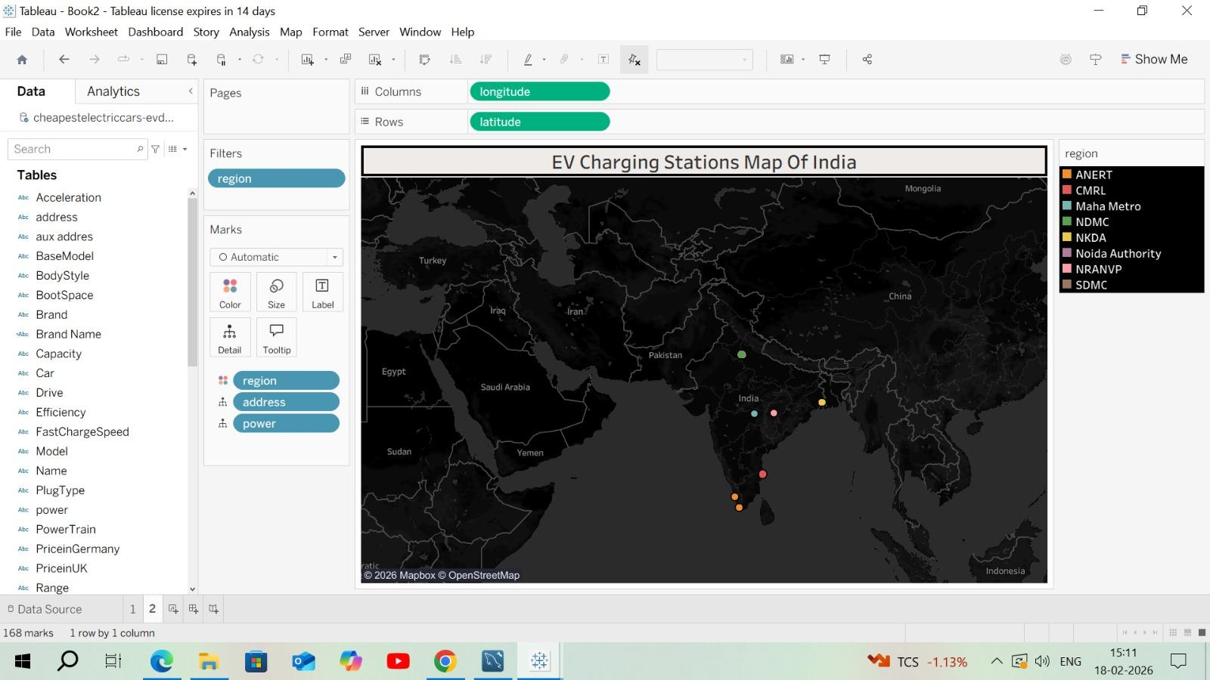

Different EV cars in India :
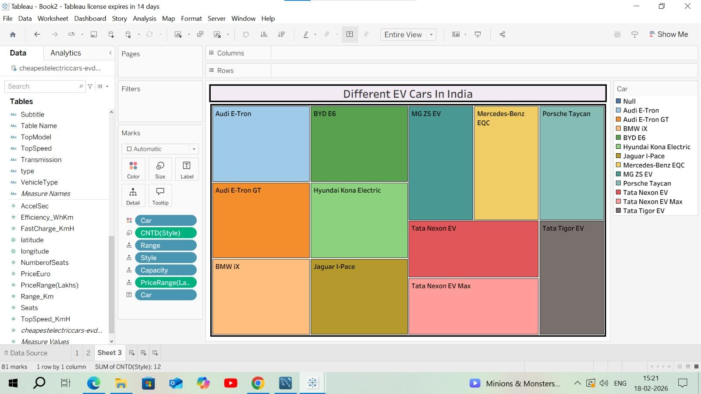

Top speed for different Brands:
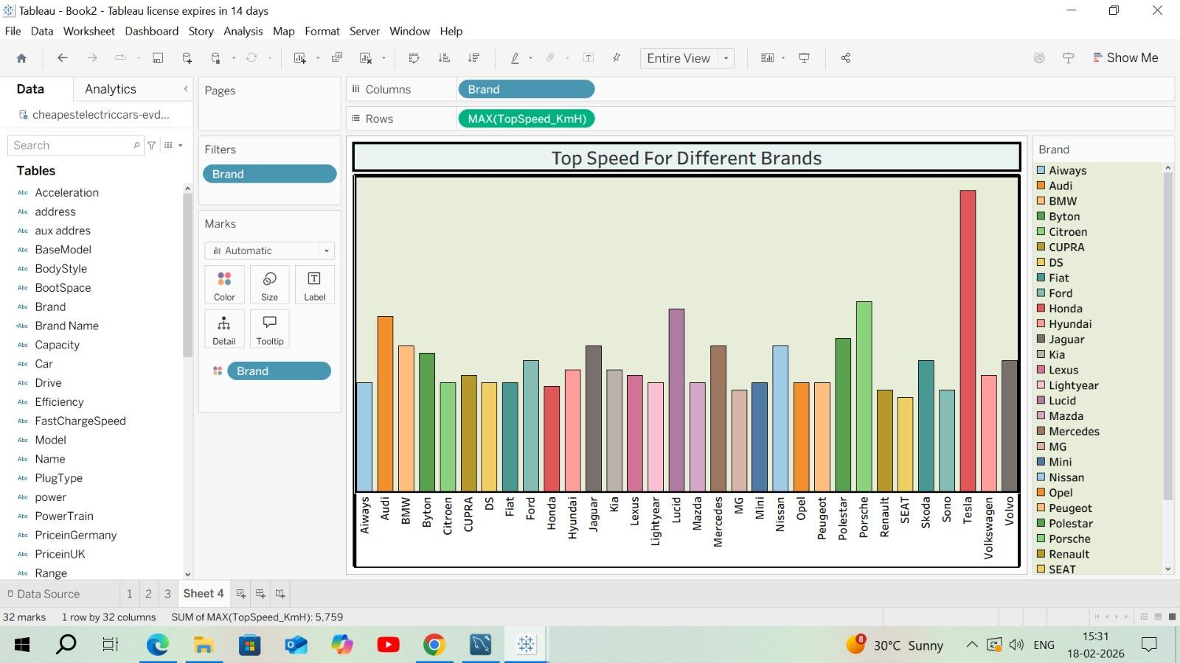
Price for different cars in India:

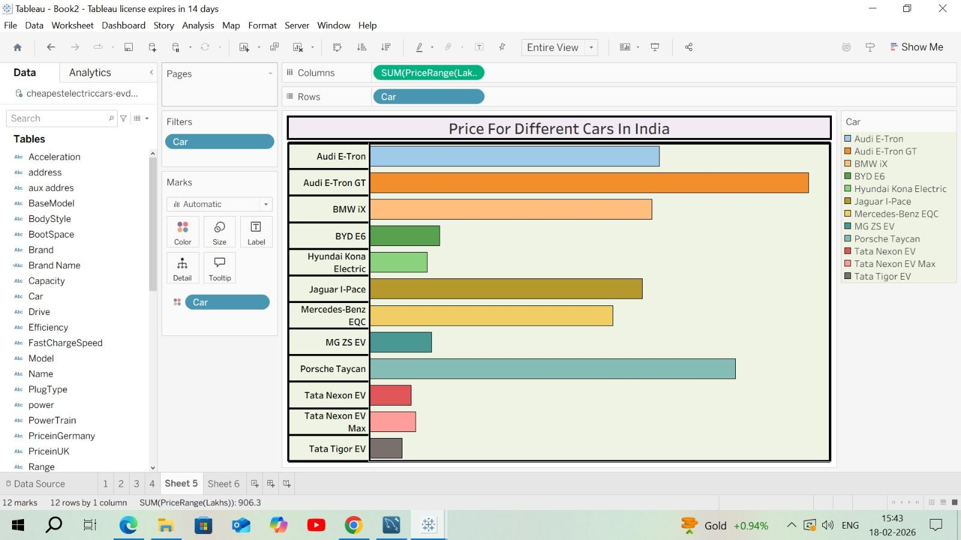

Top 10 most efficient EV Brands:
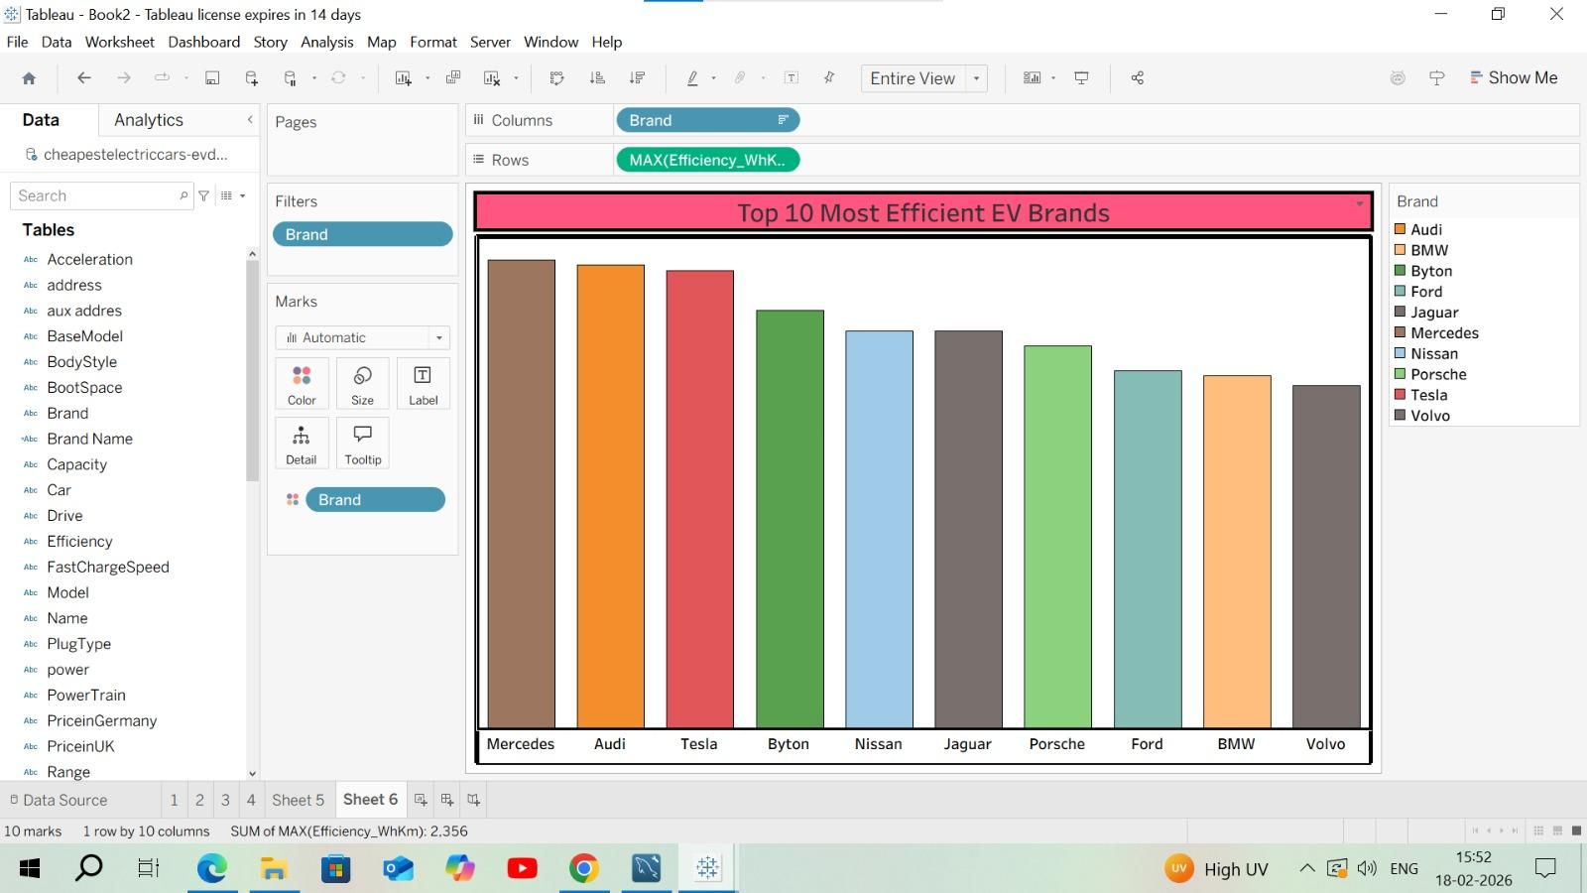
Brands according to Body style:
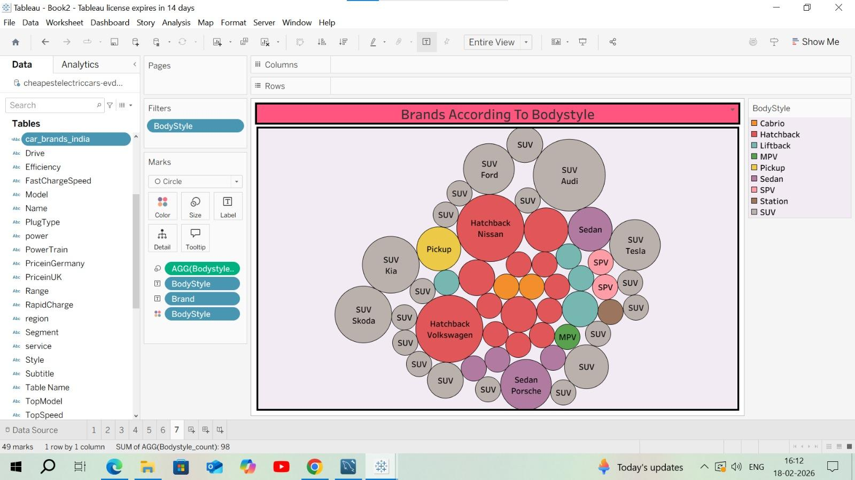
Brand filtered by Power Train type:
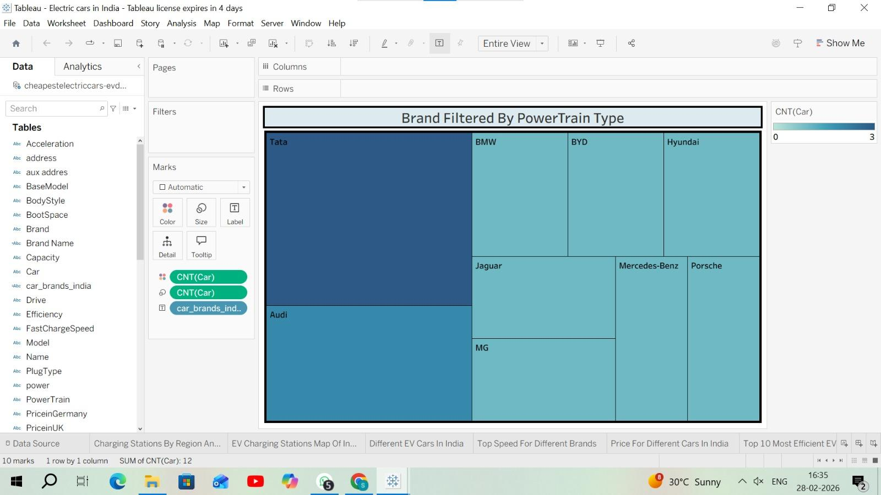
No of models by each brand:
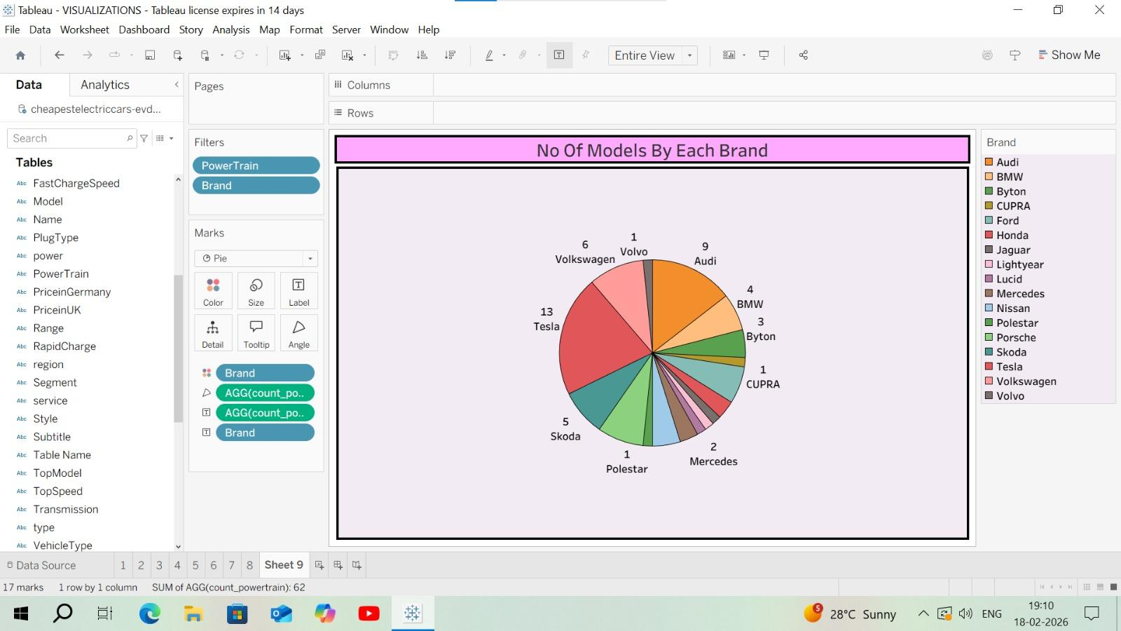
Summary card for Different brands of EV Cars globally:
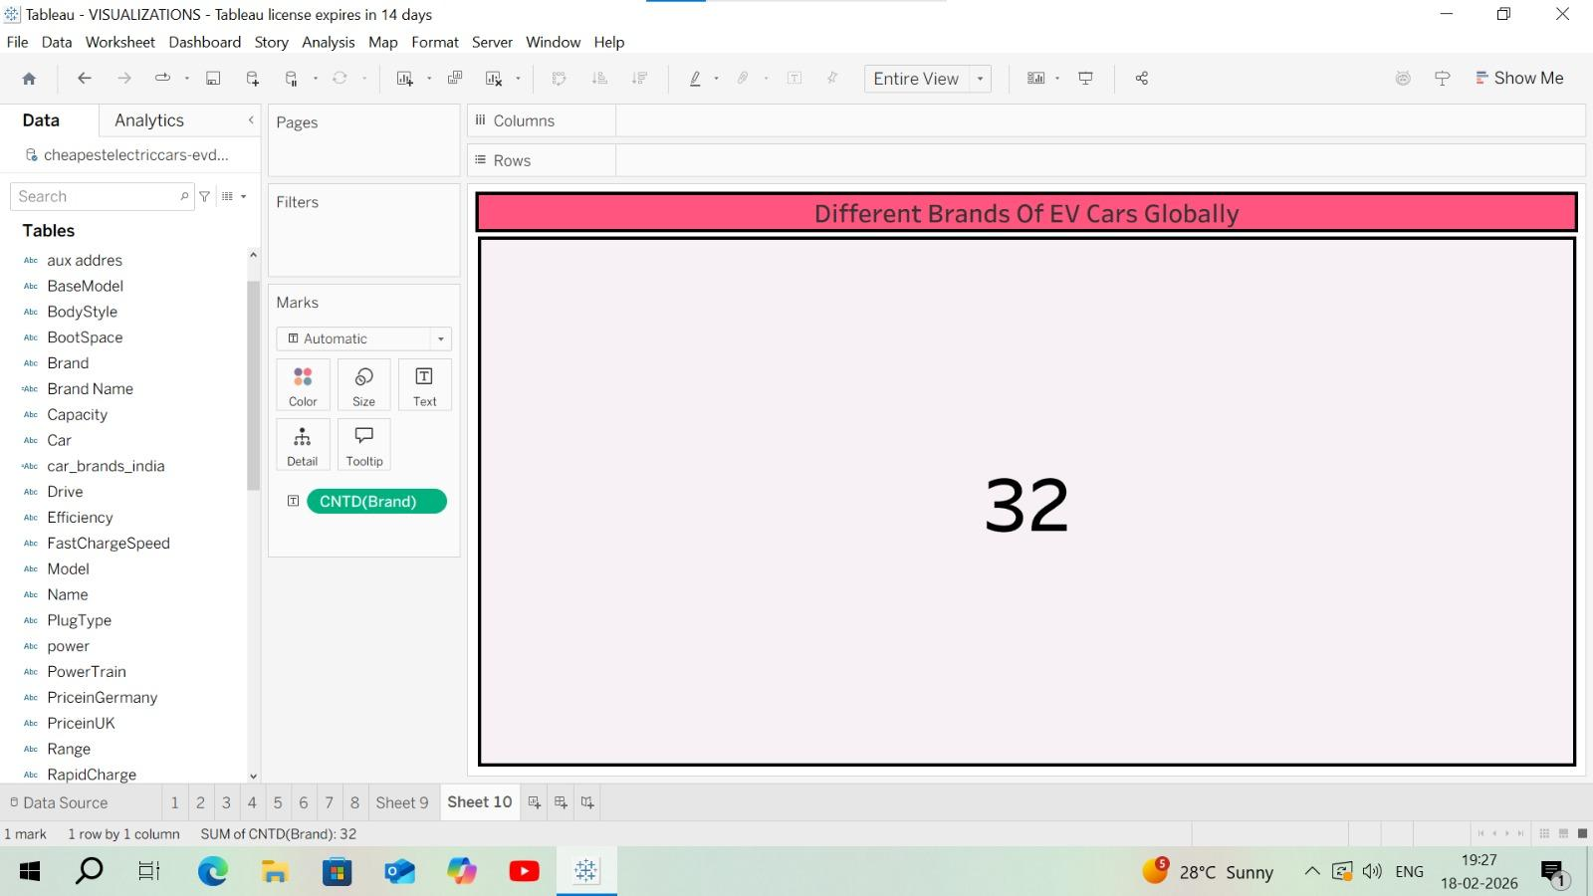
Summary card for Different brands of EV Cars in India:
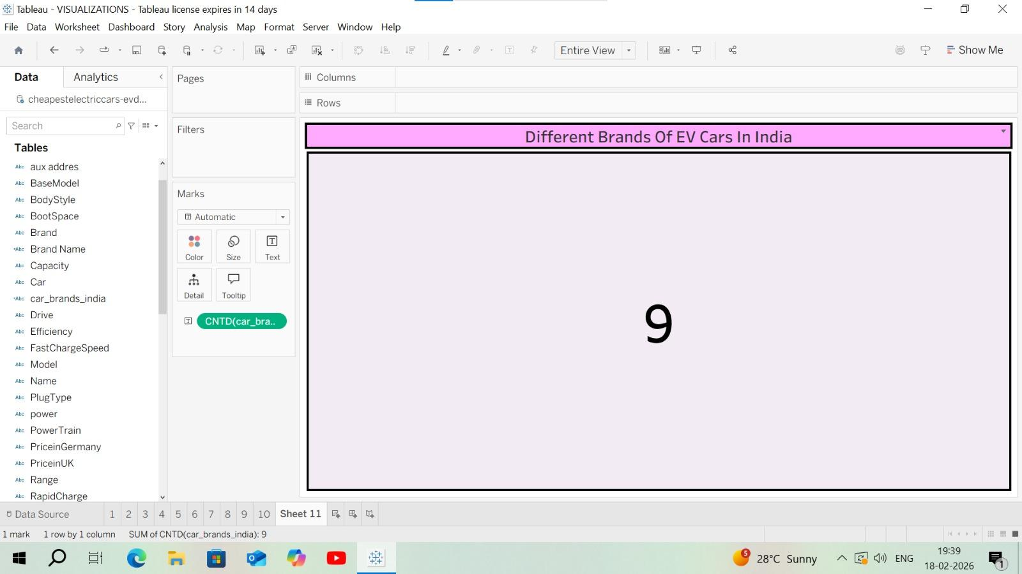

Advantages of the project
- Easy understanding of battery charge levels and remaining range
- Real-time monitoring of energy consumption
- Helps in trip planning and reducing range anxiety
- Clear comparison between different driving conditions (speed, terrain, weather)
- Supports data-driven decisions for drivers and fleet managers
- Improves charging station planning and utilization
- User-friendly dashboards with graphs, maps, and charts
Disadvantages of the project
- Accuracy depends on quality of input data
- May not fully account for sudden changes (traffic, weather, driving behaviour)
- Advanced tools can be costly
- Requires technical skills to interpret complex visualizations
- Real-time visualization may consume additional battery power
- Over-reliance can reduce driver judgment
- Data privacy and security concerns in connected systems
Conclusion:
Visualization Tools for Electric Vehicle Charge and Range Analysis Visualization tools play a crucial role in the effective analysis and management of electric vehicle (EV) charging and driving range. By transforming complex numerical data into clear graphs, dashboards, and maps, these tools make it easier to understand battery state of charge, energy consumption patterns, remaining driving range, and charging behaviour under different conditions. This improved clarity helps reduce range anxiety for drivers and supports informed decision-making for engineers, fleet operators, urban planners, and policymakers.
Advanced visualization platforms such as MATLAB, Simulink, Python-based dashboards, Tableau, and GIS tools like QGIS enable both real-time monitoring and predictive analysis. They allow users to simulate different driving scenarios, battery capacities, charging strategies, and environmental conditions, which is essential for optimizing vehicle performance and planning efficient charging infrastructure. As EV adoption grows, such tools also support large-scale fleet management and smart-grid integration.
10. FUTURE SCOPE
The future scope of visualization tools for electric vehicle (EV) charge and range analysis is highly promising as electric mobility continues to expand worldwide. With rapid advancements in battery technology, data analytics, and connectivity, visualization platforms are expected to become more intelligent, predictive, and user-centric. These tools will move beyond basic monitoring of state of charge and remaining range to provide deeper insights into vehicle performance, energy efficiency, and charging behaviour under real-world conditions.
One major area of future development is the integration of artificial intelligence and machine learning into visualization systems. By combining historical and real-time data, tools developed using platforms such as Python analytics frameworks and simulation environments like **MATLAB / Simulink will be able to accurately predict driving range, battery degradation, and optimal charging times. This will help drivers and fleet operators plan trips more efficiently and reduce energy costs.
11. APPENDIX
Source Code(if any)
Dashboard Publishing:
https://public.tableau.com/app/profile/kinjarapu.sukanya/viz/StoryElectriccarsinIndia/Dashboard1
Story:
https://public.tableau.com/app/profile/kinjarapu.sukanya/viz/ElectriccarsinIndia/StoryofElectriccarsinIndia
Flask:
https://drive.google.com/drive/folders/1NrBRmkHZGq1LndI04yspeFUn8awLywVn?usp=sharing
Dataset:
https://drive.google.com/drive/folders/1Rkzdks6Us1Uq2SRB4nxMAb83jN5bpHll

